The python file: “flip_all_bits.py”
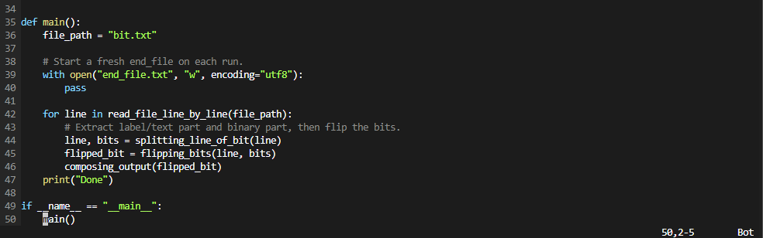
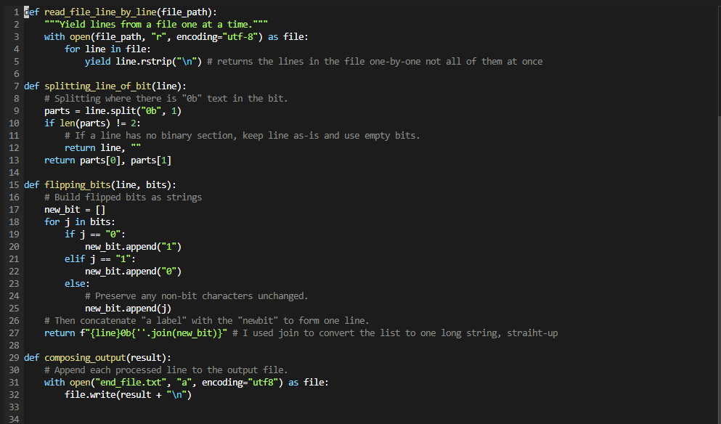

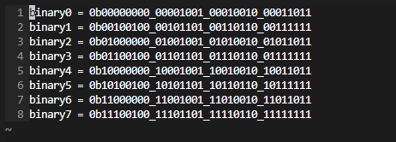
My input file: “bit.txt”

The readme file: “readme.md”
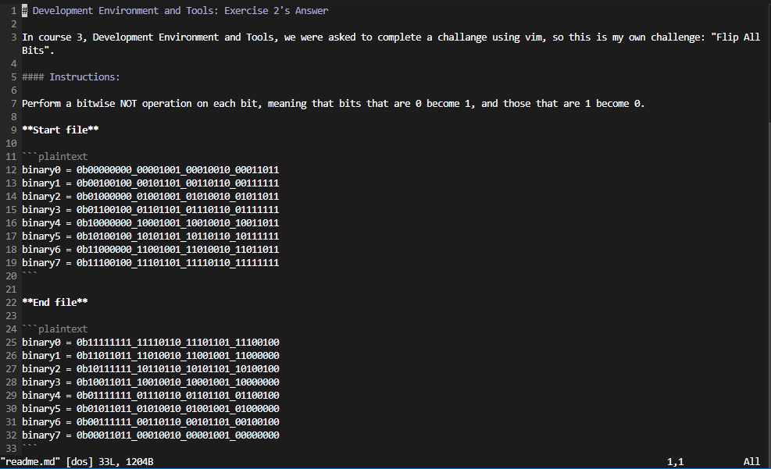
My terminal: “wsl Ubuntu”

